S

The Wealth Of Nation

DATA VISUALIZATION

**Sangeetha Palaniandi**

15th Feb 2023

Contents

Assignment 1 Data Visualisation: 2

Scenario: 2

First Task: 2

Policies and Procedures: 2

Second Task: 3

Third Task: 16

# **Assignment 1 Data Visualisation:**

# **Scenario:**

* Data visualisation helps to tell stories by curating data into a form that is easier to understand, highlighting the trends and outliers.
* A good visualisation tells a story, removing the noise from data and highlighting the useful information.
* I have been asked to examine the data workbook and become acquainted with this information.
* I have also been tasked with utilizing Tableau to produce a visual report that would meet the needs of the client by displaying the data as maps and charts.

# **First Task:**

## **Policies and Procedures:**

* Ensure data privacy and security.
* Ensuring data privacy and security is important in order to protect data from unauthorized access or manipulation.
* In order to prevent data breaches and other malicious activities.
* In order to ensure that data is not misused or abused.
* This essential for any organization that handles sensitive data or collects personal information from users.
* Ensure data accuracy and integrity.
* Ensuring data accuracy and integrity is important in order to maintain the accuracy and trustworthiness of data,
* In order to make sure that data is reliable and can be used for making decisions.
* In order to ensure that data is protected from unauthorized access or manipulation.
* Monitor data regularly for compliance and accuracy.
* Monitoring data regularly for compliance and accuracy is important in order to ensure that all data is accurate and up to date.
* This is especially important in industries such as healthcare and finance, where data accuracy and compliance are essential for providing quality services.
* Regular monitoring of data helps to ensure that any discrepancies are identified quickly and any necessary corrections are made. It also helps to ensure that data is compliant with any applicable laws or regulations.
* Follow all applicable laws and regulations related to data collection and processing
* In order to ensure that data is handled responsibly and in compliance with applicable laws.
* Laws and regulations related to data can vary depending on the region and industry, and it is important to be aware of any applicable laws and regulations in order to ensure compliance.
* helps to protect data from misuse or abuse and helps to ensure that data is collected and used responsibly.
* Provide transparency on how data is collected, used, and shared.
* In order to ensure that data is being handled responsibly and in an ethical manner.
* To ensure that data is used for legitimate purposes and is not misused or abused.
* To ensure that data is used only for the purposes for which it was collected and is not shared without the consent of the data subject.

# **Second Task:**

1.Protect the work book, setting password.

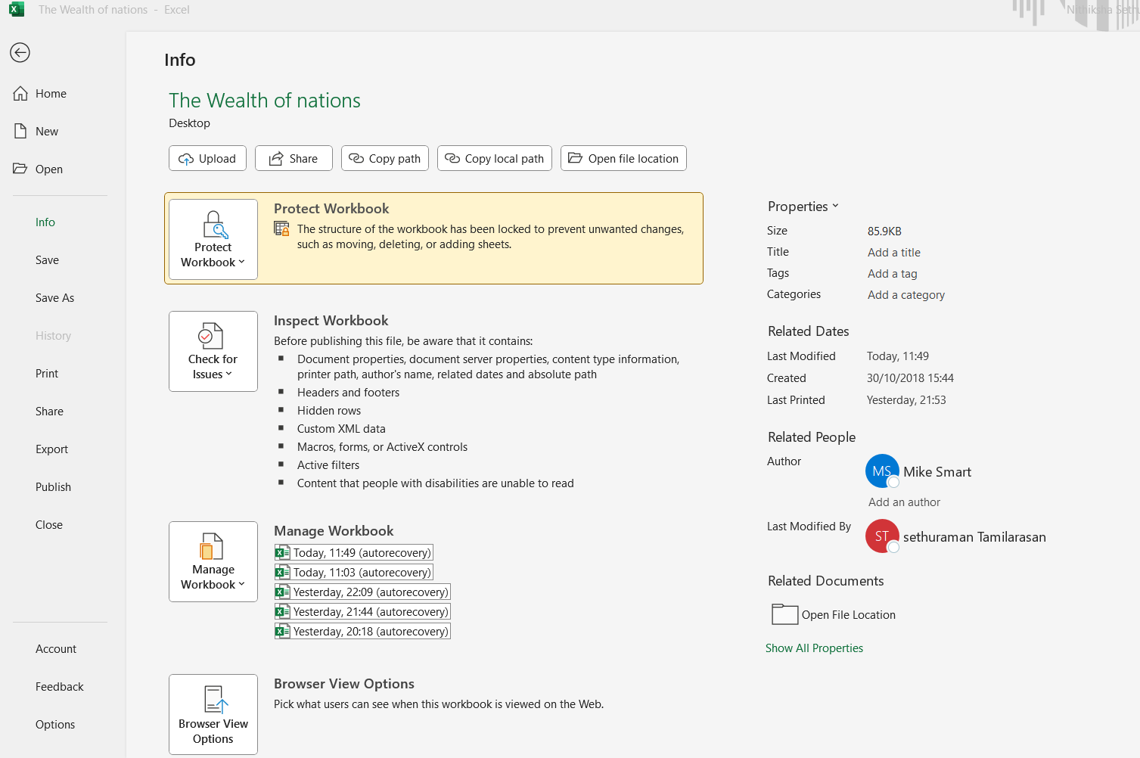

* Select the HOME, click INFO .
* Select Rescrit access and set the password to protect the worksheet.

2. Highlight column C and change the data to display in British Pound symbol

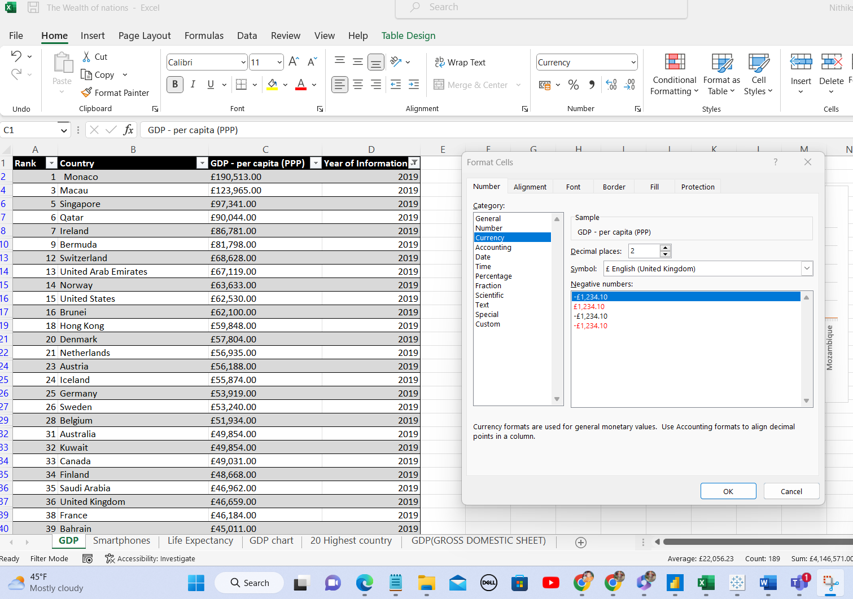

* Select column C and right click the cursor.
* Select the format cells.
* Check the currency symbol and change the currency value into British Pound value.

3. Turn the GDP sheet into a table.

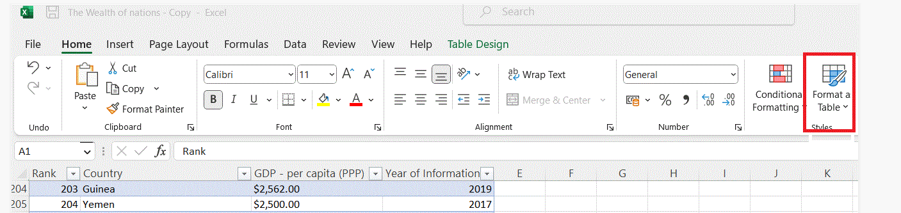

* Select a cell within your data.
* Select Home and Format as Table.

4. Filter the table to display only the information for 2019

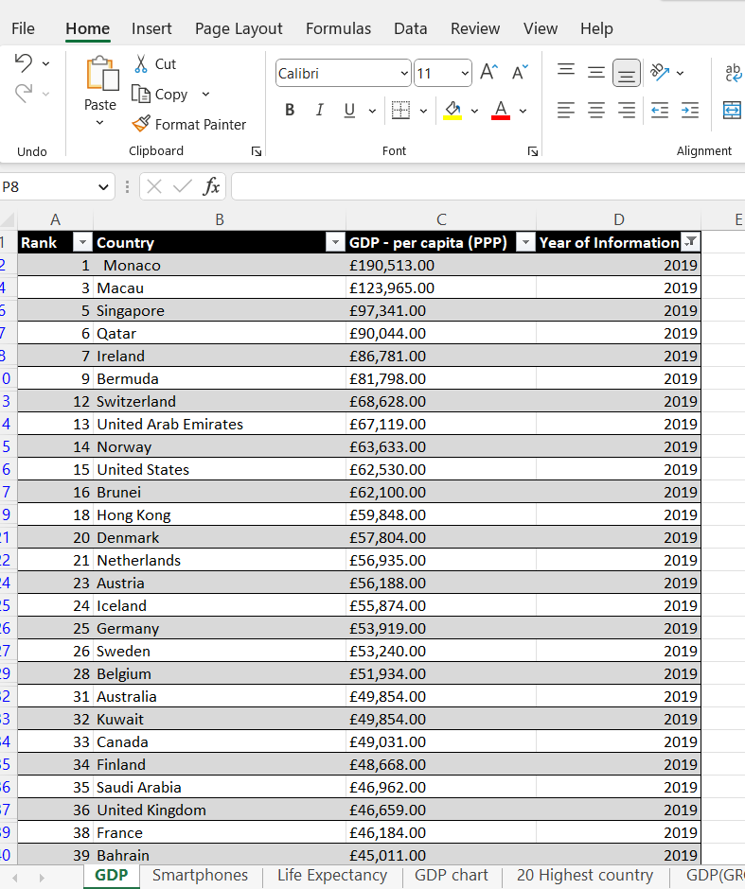

* Select Data from tool-bar and Filter.
* Select the column header arrow, within Number Filters select only 2019.

5. Next create a chart that will only display the following data ‘Rank, Country and GDP - per capita (PPP).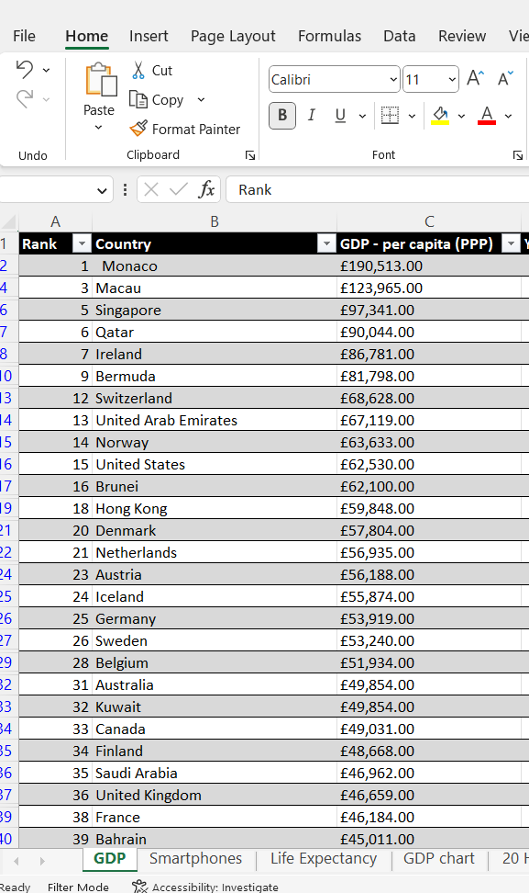

* Select all the cell values of Rank, Country and GDP to create a chart.
* Click INSERT for recommended Charts.

6. Using your creative skills edit the chart

* a. Add a title
* b. Add X and Y axis labels
* c. Make the chart visually pleasing
* Select marked Icon to create the chart elements.

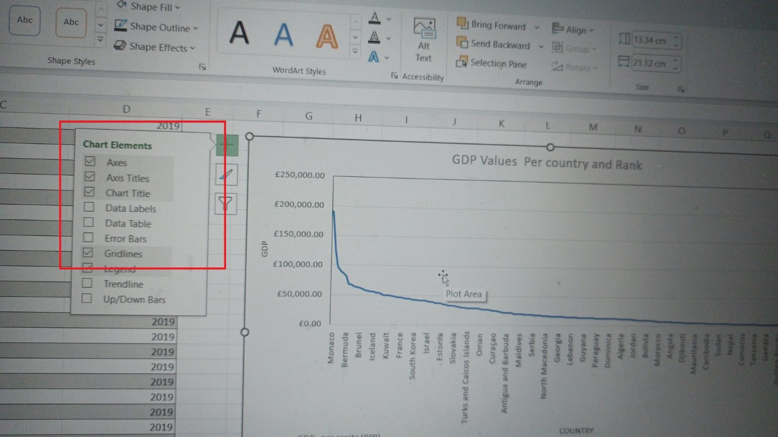



7. Move the chart to a new sheet tab and label with a suitable name.

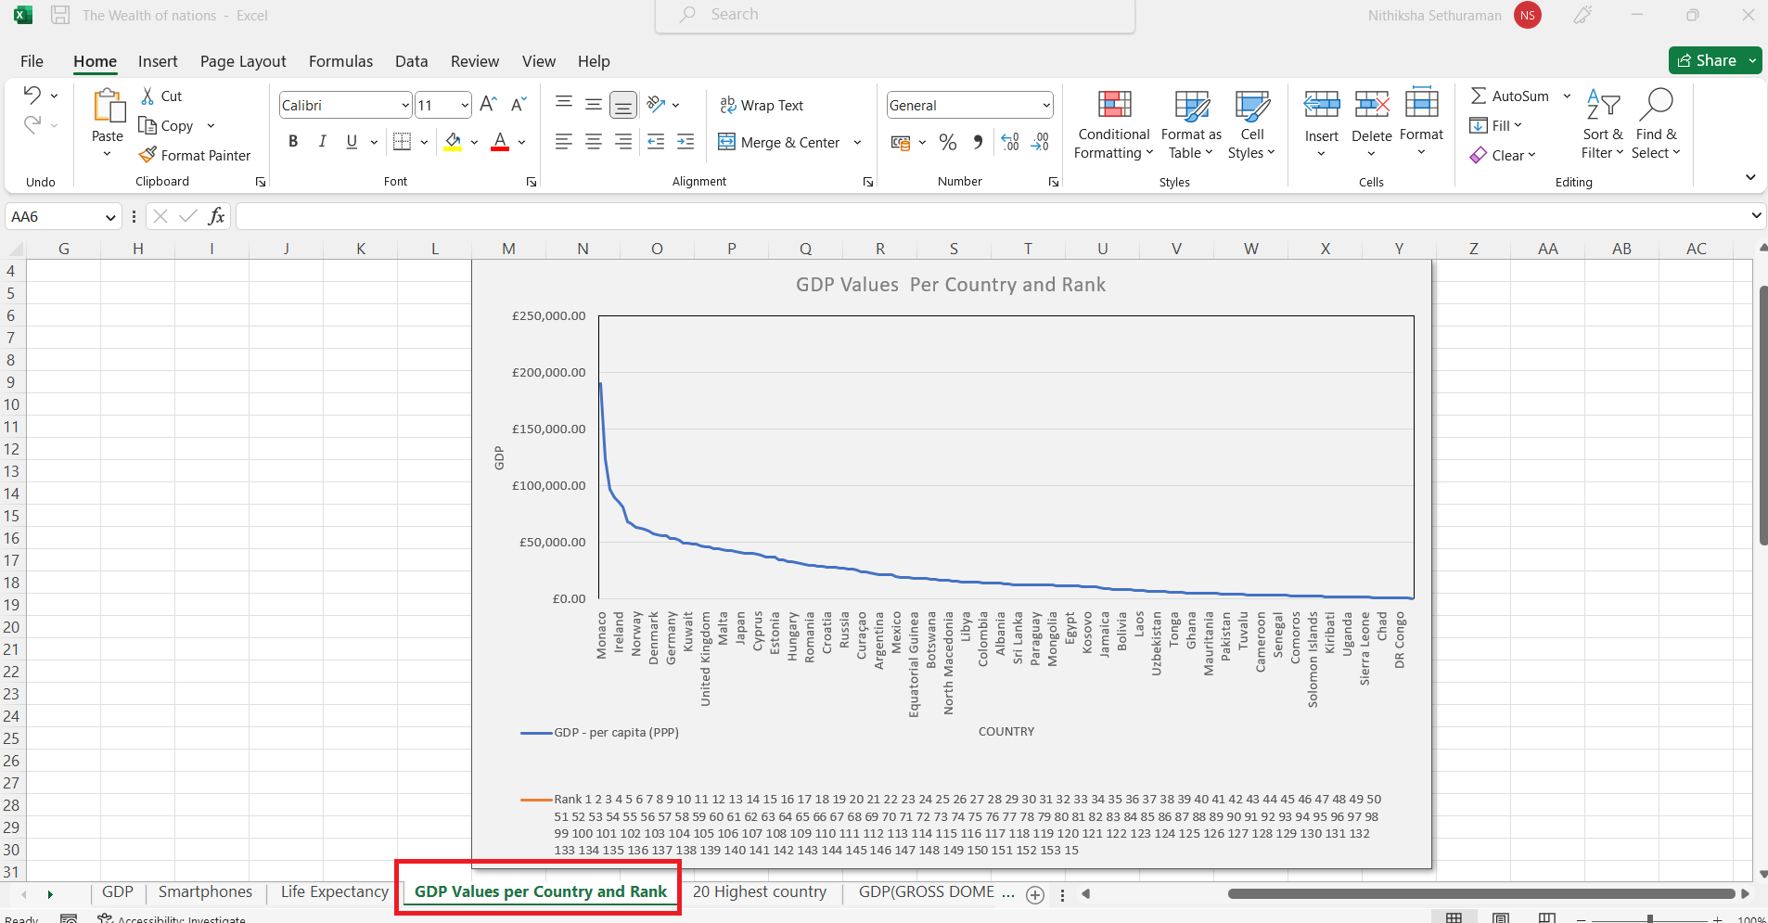



* Right-click the **sheet** tab, click **Rename**, and then type the new name.
* Check the highlighted area.

8. Create a sort for the top 20 highest ranking counties.

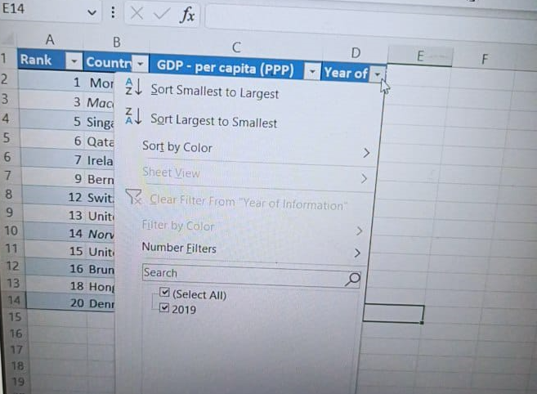

* Select Data and Filter.
* Select the column header arrow .
* Filter Year 2019 and Top 20 countries.

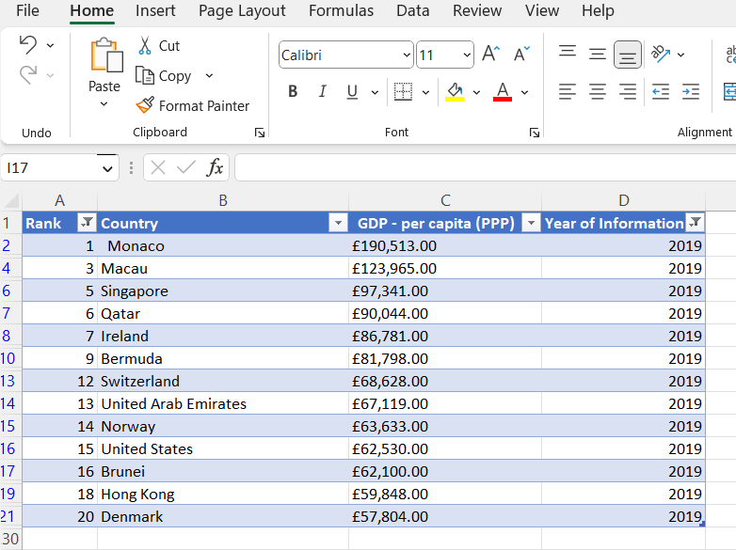

9. Next create a new Bar chart to display the 20 highest ranking countries from your sort and then move the chart to be underneath the table.

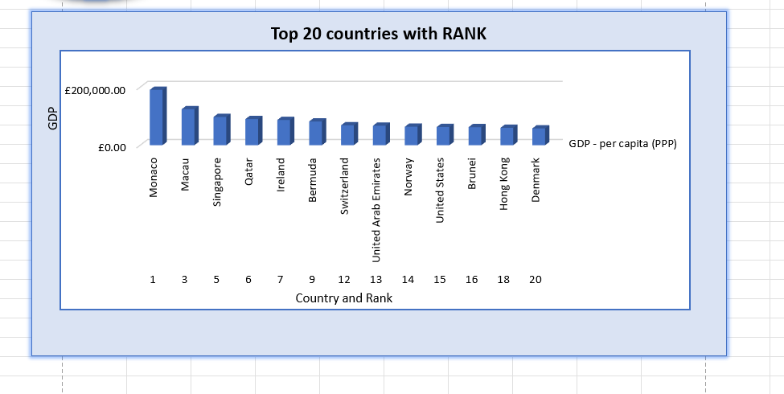

11. The next task is to create 3 macro buttons, print the sheet, Save the file and Copy the sheet.

* Insert tab and select Shapes of



* To create Copy, Save and Print macros.
* Select view and Macros from toolbar

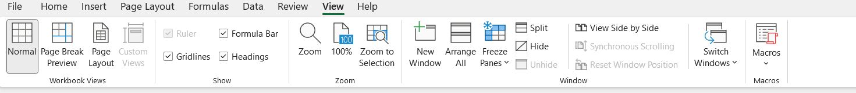



Select record macros from the tab.

* Optionally, enter a name for the macro in the Macro name box, enter a shortcut key in the Shortcut key box, and a description in the Description box.

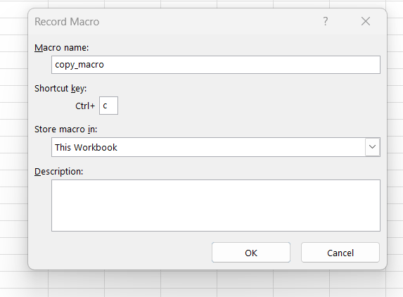

Click OK to start recording.

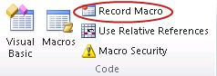

* Perform the actions Record Copy, Print. Once finished it click Stop Recording.

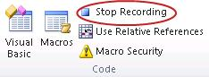

14. Next assign the macro to the copy button.

**Run a macro from the Developer tab**

* + Open the workbook that contains the macro.
  + On the Developer tab, in the Code group, click Macros.
  + In the Macro name box, click the macro that you want to run, and press the Run button.

**Assign a macro from the Developer tab**

* Click File > Options > Quick Access Toolbar.
* Choose commands from list, click Macros. Select the macro you want to assign a button to.
* Click Add to move the macro to the list of buttons on the Quick Access Toolbar.

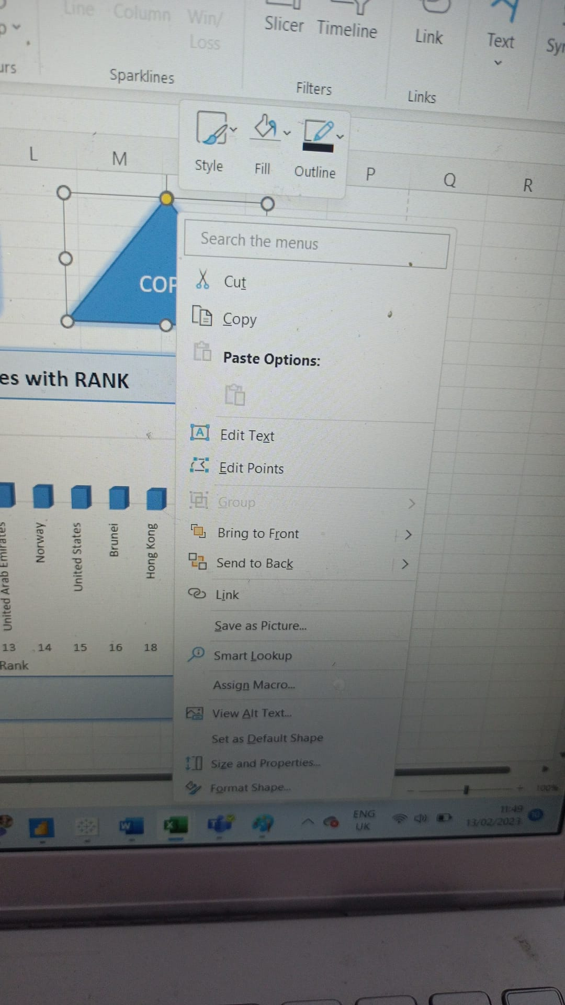



14. Before we finish with our excel table ‘Gross domestic product’ sheet, we will add a header and footer to our table. Select the ‘View’ tab from the top and find the ‘workbook views’ area, as seen below.

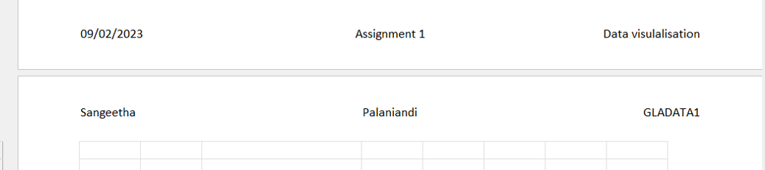

17. Return your view to normal

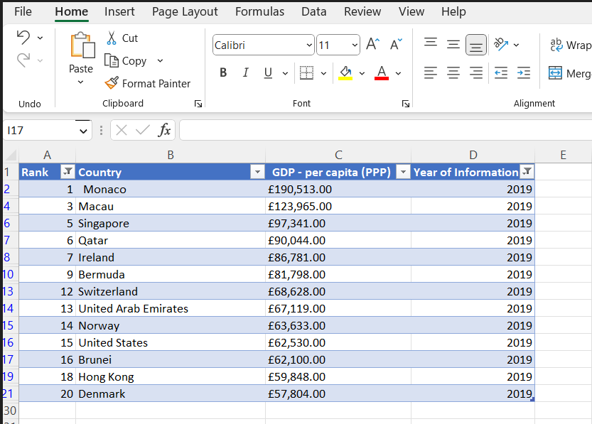

18. Save your table as ‘Excel Gross domestic product report 1’

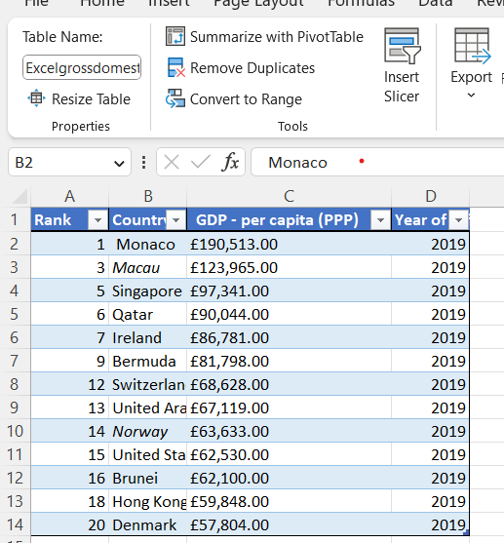



# **Third Task:**

**1) Import Data**

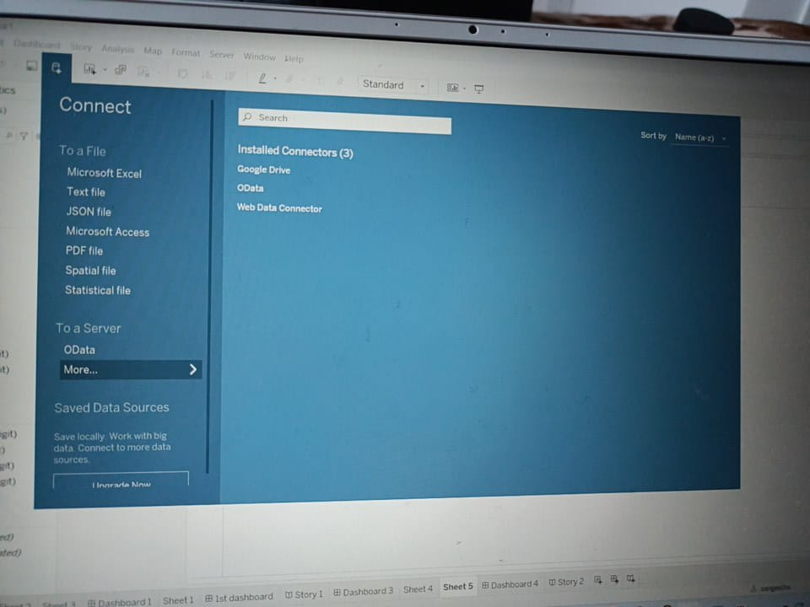

* First, click on "Microsoft Excel" under the connect tab.
* It will open a dialog box where you can navigate to the Excel file in your machine from which you want to import the data.
* Click on the file and click on ‘Open’. If there are multiple sheets in your Excel workbook, all of them will be imported automatically
* They will be listed as sheets on the left-hand side panel of Tableau.

**2) Set Relationships:**

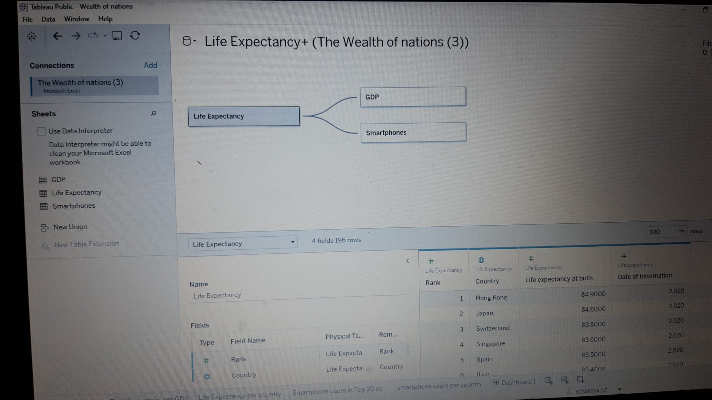

**Create a relationship**

* Drag a table to the canvas.
* Drag another table to the canvas. When you see the "noodle" between the two tables, drop that table. The Edit Relationship dialog box opens.
* Link with country element set relationship between tables.

**Charts:**

**Top 20 countries - GDP value:**

**GDP:**

* **GDP stands for Gross Domestic Product and is a measure of the economic output of a country or region.**
* **It is a comprehensive measure of the market value of all goods and services produced in a particular period of time.**
* **GDP is used by governments and economists to measure and evaluate the economic health of a nation.**
* **It is also used to compare the economic performance of different countries.**

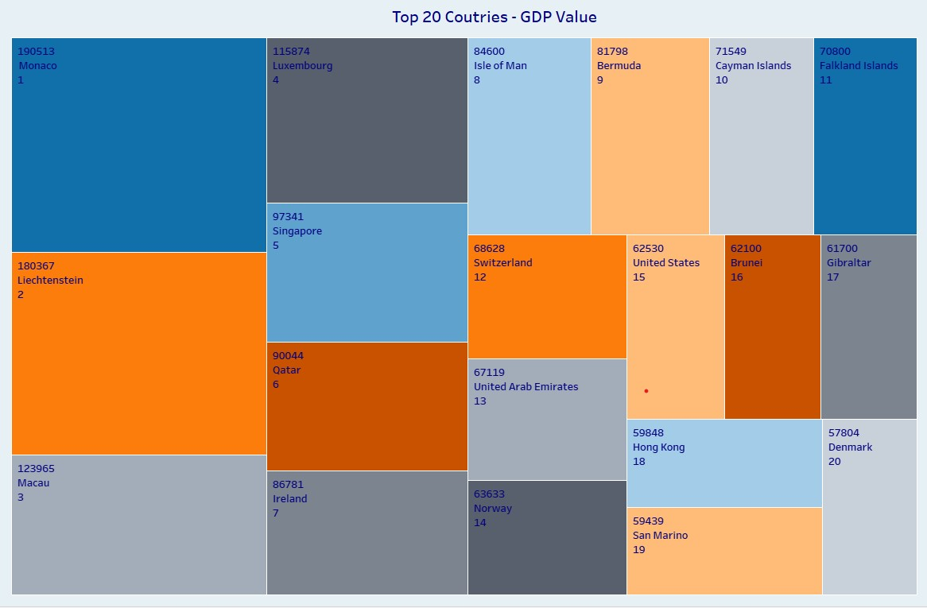

**Top 20 countries – Smart Phone Users:**

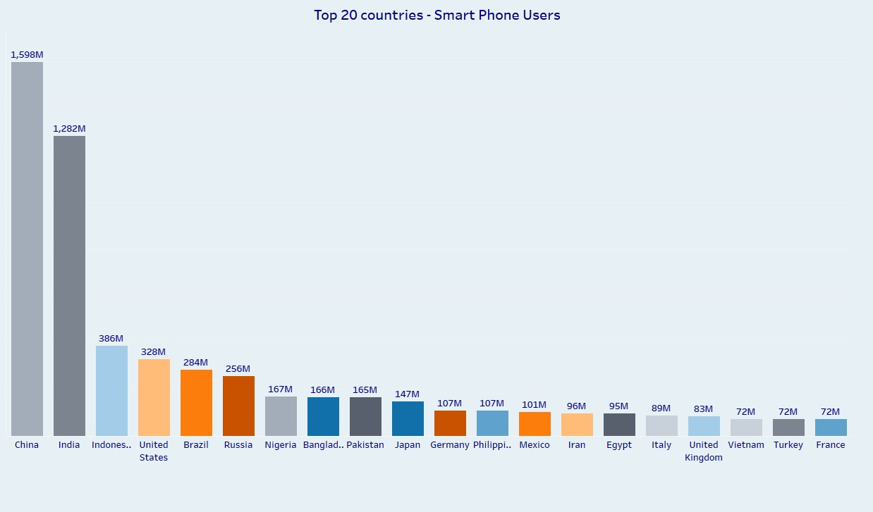

**Top 20 Countries – Life Expectancy:**

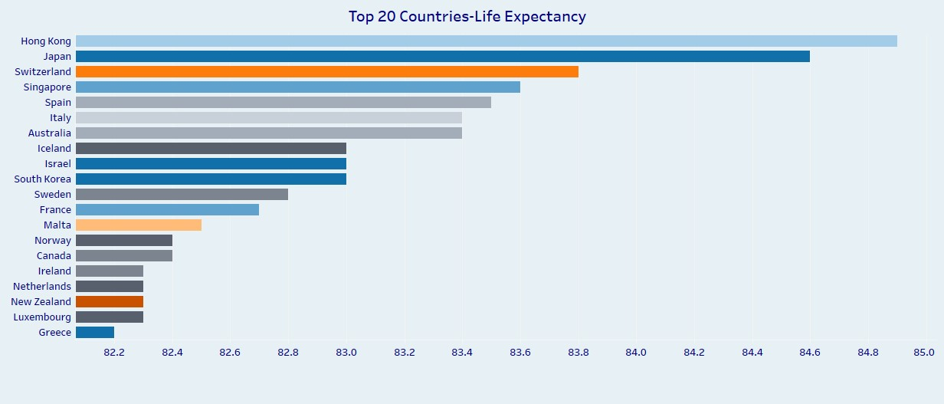

**Gross Domestic Product – Map:**

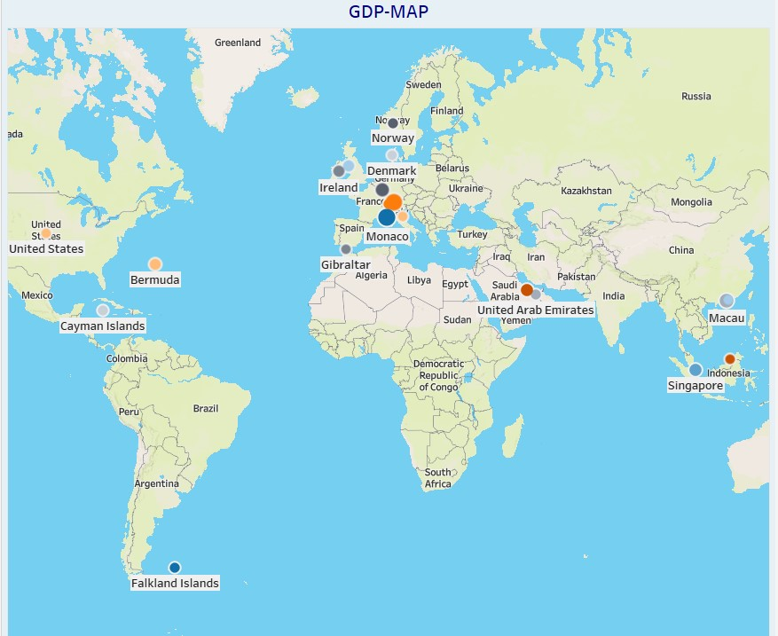

**The Wealth Of Nation:**

* **It is considered to be the foundation of modern economics. The wealth of nation is usually measured by its GDP(Gross Domestic Product),**
* **GDP stands for Gross Domestic Product and is a measure of the economic output of a country or region.**
* **GDP is the total value of all goods and services produced within**

**a country in a given year.**

* **GDP is typically divided into 4 components which are personal consumption,investment,government spending and net exports.**
* **It is also used to compare the economic performance of different countries.**

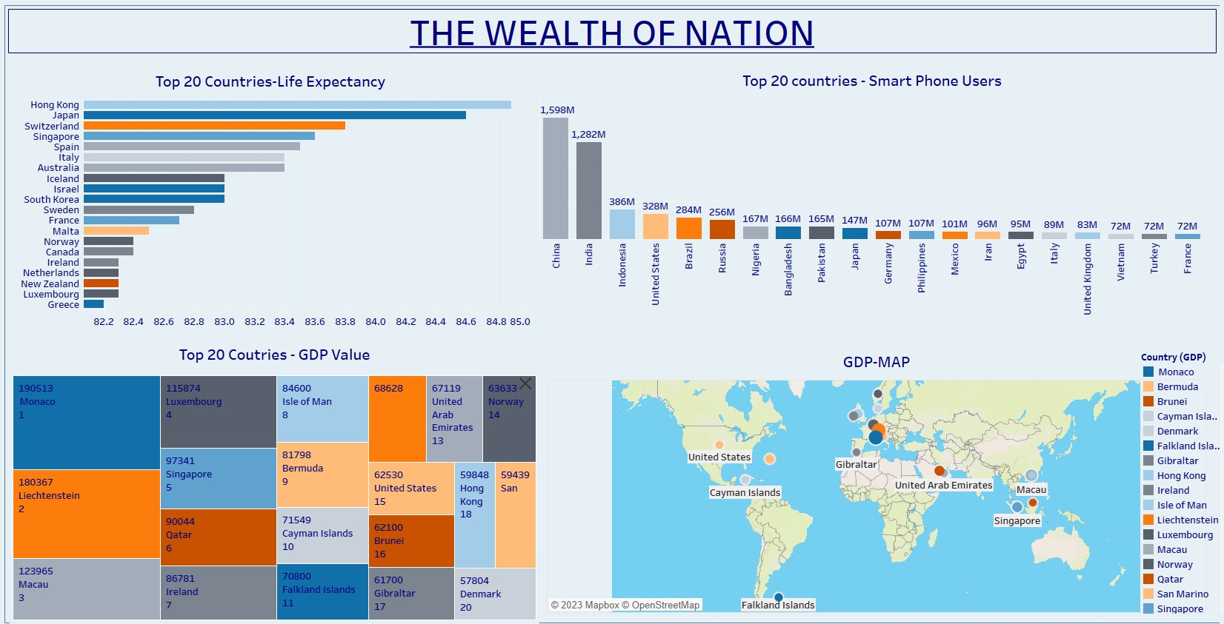

Reference:

<https://public.tableau.com/app/profile/sangeetha4524/viz/Sangeetha/TheWealthOfNation?publish=yes>

**Thank You**